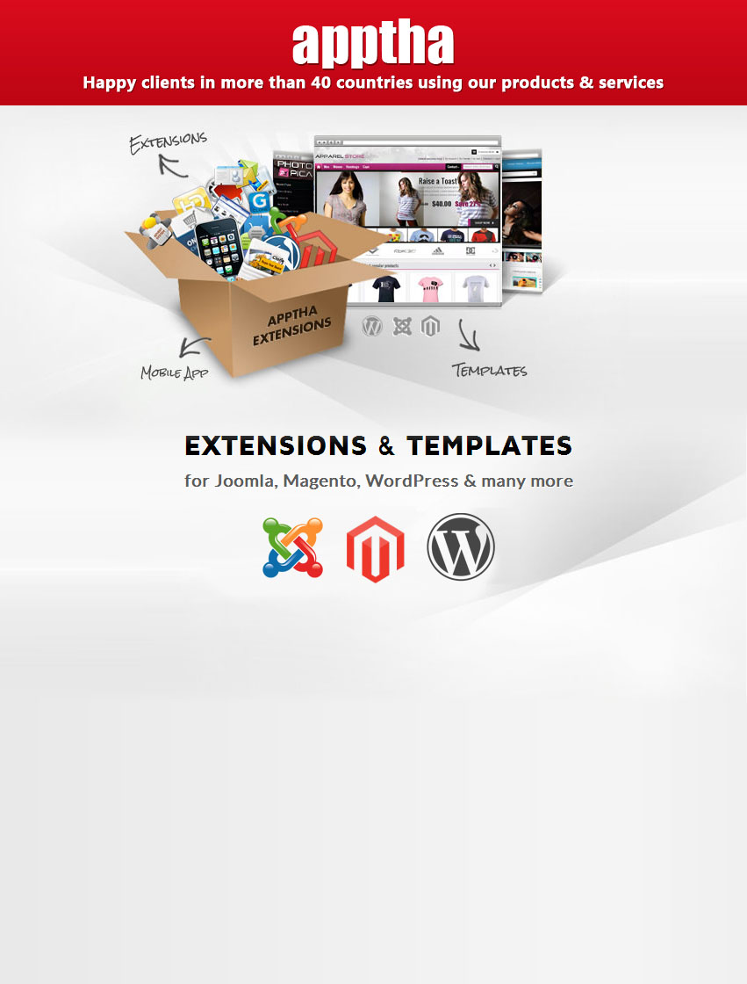

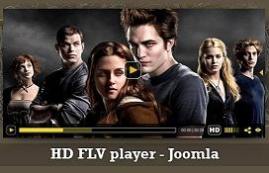

HD FLV Player for Joomla

Product version: 2.1

Compatible: Joomla 1.5, 1.6, 1.7, 2.5 & 3.0

User Manual

HD FLV Player! Brings life to Joomla pages by allowing you to play popular video formats such as MP4, M4V, M4A, MOV, Mp4v, and F4V in different browsers. With some salient features like HTML support to play videos in iPhones & iPads, Lighttpd & RTMP streaming, Monetization, Native language support, and Social Bookmarking, the player promises to be ultimately unique.

Table of Contents

Preface ……………………………………………………………………………………….……….4
- About This Document …………………………………………………………………………………………….4
- Updates, Comments, and Suggestions ……………………………………………………….………..4
- Disclaimer ……………………………………………………………………………………………………………….4
HD FLV Player for Joomla ..……………………………………………………………….…….5
- HD FLV Player Component ……………………………………………………………………………………..5
- HD FLV Player Module ...………………………………………………..……………………..……………….5
- HD FLV Player Plugin ………………………………………………………………………………..…………….5
- Downloading HD FLV Player………………………………………………………………….….……..………5
Installation Steps ……………………………………………………………………………...…..7
HD FLV Player Component ………………………………………………………………....….11
- Videos …………………………………………………………………………………………………………………….15
- Player Settings ……………………………………………………………………………………………….………19
- Playlists …………………………………………………………………………………………………………….…….25
- Language Settings ……………………………………………………………………………………….…………25
- Video Ads ………………………………………………………………………………………………………….…….26
- Google Adsense …………………………………………………………………………………………….………..28
HD FLV Player Module …………………………………………………………………….....….29
- Using HD FLV Player Module …………………………………………………………………………...……29
HD FLV Player Plugin …………………………………………………………………………....34
- Using HD FLV Player Plugin ……………………………………………………………………………...…..34
Basic Requirements for Joomla ………………………………………………………..…….38
Contacting Us ……………………………………………………………………………….……..42

Preface

About This Document

This document provides information on how to download, install, configure, and use HD FLV Player for Joomla.

Updates, Comments, and Suggestions

Please forward your valuable comments, suggestions, or questions about the information contained in this document to support@apptha.com.

Disclaimer

Apptha reserves the right to add, remove, or modify business models or processes related to packaging, selling, marketing, developing extensions and themes of Apptha.com, at any time and without prior notification.

Apptha reserves the right to add new features to its products based on research and market needs. Apptha reserves the right to remove any feature of its products that does not fulfill expectations.

HD FLV Player for Joomla

HD FLV Player Component:

It is the main functional unit of Joomla HD FLV Player, which typically adds web video player to your Joomla Site with the most advanced configurable options for playing or streaming videos on browsers. This Joomla Component is usually displayed in the main body area of a template (depends upon on the template).

- Display area: Content of the webpage

HD FLV Player Module:

It is lightweight and flexible unit of Joomla HD FLV Player, which is used to display web video players in small bits (usually along the side, top, or bottom of the main body) on the page that is generally less complex and able to be seen across different components. This module is linked to HD FLV Player component and it has fewer options that are configurable by end users.

- Display area: Not The "periphery" of a page: Sidebar, header, footer, etc.

HD FLV Player Plugin:

It is a piece of code which extends the basic functionality of Joomla by providing an opportunity to display web players in all Joomla articles and pages. The piece of code is called as “plugin code” which is an extended functionality of the component and it does not contain any additional settings, but the default settings (component) can be overridden using the own parameters of plugin code.

- Display area: Anywhere in articles and pages.

Downloading HD FLV Player?

HD FLV Player for Joomla is available in two different versions namely Free Version and Pro Version.

- Free Version (Branded): This version comes at free of cost. It is suitable for non-commercial needs. In this free player, our demo logo serves the branding purpose.

- Pro Version (No Branding): By applying the commercial license to the player, you can remove our demo logo effortlessly. It is suitable for commercial businesses since they require no branding. The commercial license can be purchased for your website by offering a onetime fee for brand removal.

Links to download HD FLV Player trail/free version for Joomla: The player can be downloaded by clicking the link “Trial Download” below.

- Apptha: http://www.apptha.com/category/extension/Joomla/HD-FLV-Player

Links to buy HD FLV Player commercial license for Joomla: The Commercial license can be purchased by clicking the button “Buy Now” in the following page..

- Apptha: http://www.apptha.com/category/extension/Joomla/HD-FLV-Player

Installation Steps

Installing HD FLV Player is really straightforward. After downloading the file, make sure you extract it beforehand.

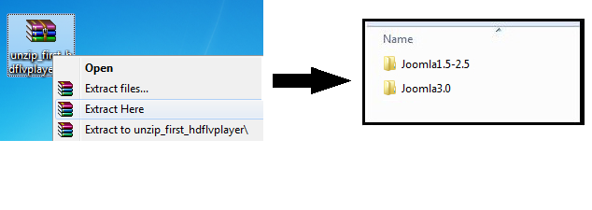

You have to choose a file based on the Joomla version you use.

- Login to your Joomla administration area and go to Site → System Information → Directory Permission. Make sure all directories listed are writable.

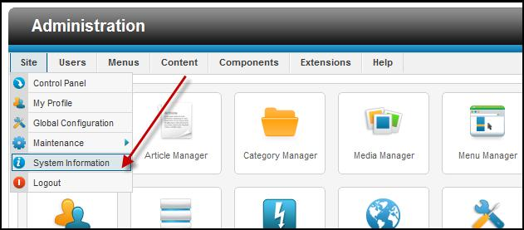

46 | Page

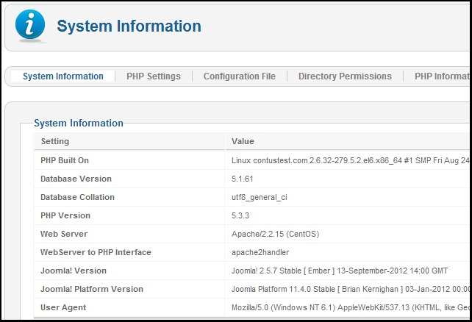

- Go to Extensions > Extension Manager. At Upload Package File, browse for the HD FLV Player file and choose it. Then, click on "Complete your installation" to begin.

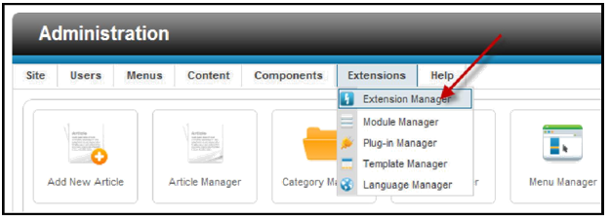

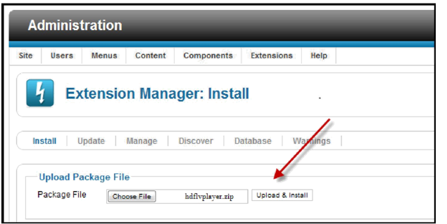

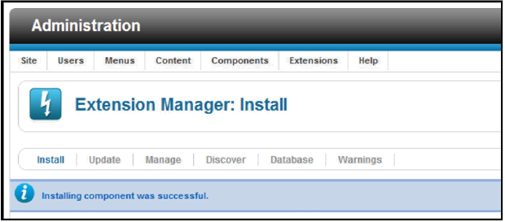

3. Open the checklist of HD FLV Player screen and make sure all the requirements are highlighted in green color. If any requirements are mentioned in red, then you need to verify requirements before start using it.

Go to Components → HD FLV Player → Checklist

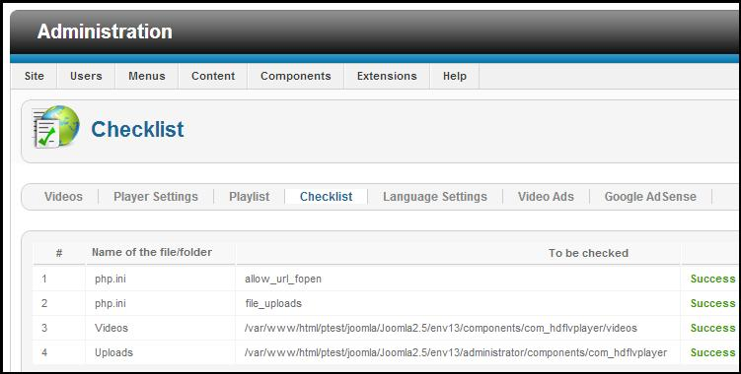

- You have completed installation successfully. Congratulations!

Alternate Installation Steps:

You can also install HD FLV Player by manually uploading all the files to your web host via FTP.

- Extract the HD FLV Player zip folder completely.

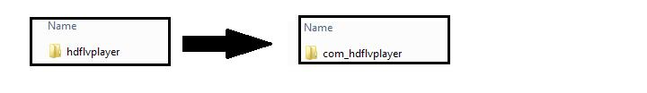
2. Upload the extracted folder to your Joomla/tmp directory using your FTP client.
3. Go to Extensions > Extension Manager. At the "Install from Directory" section, point to the folder that you have uploaded just now. Then click “Install.”

2. Upload the extracted folder to your Joomla/tmp directory using your FTP client.
3. Go to Extensions > Extension Manager. At the "Install from Directory" section, point to the folder that you have uploaded just now. Then click “Install.”

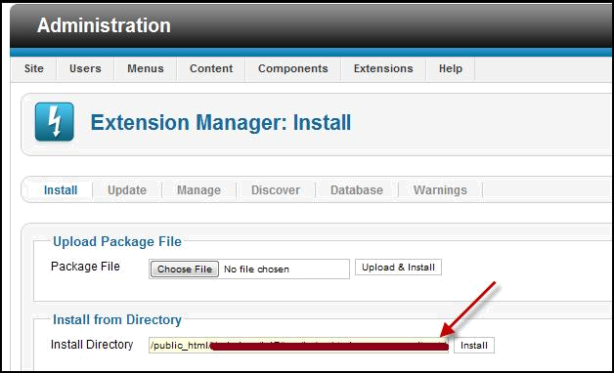
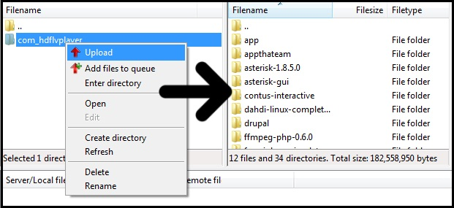

HD FLV Player Component

Using HD FLV Player Component:
To use HD FLV Player component, you need to create new menu item for “HD FLV Player” menu item type.
Steps:

- Choose Menus → Menu Manager to open Menu Manager.

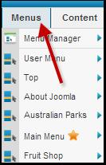

- Click the name of the menu that you want to add a new menu item to. The Menu Item Manager Opens.

- Click the New button to open new menu item creation page.

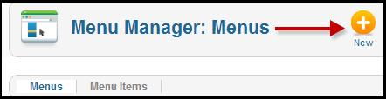

- Select a Menu Item Type as “Player” from “HDFLV Player” and enter required details such as Menu Title, etc.

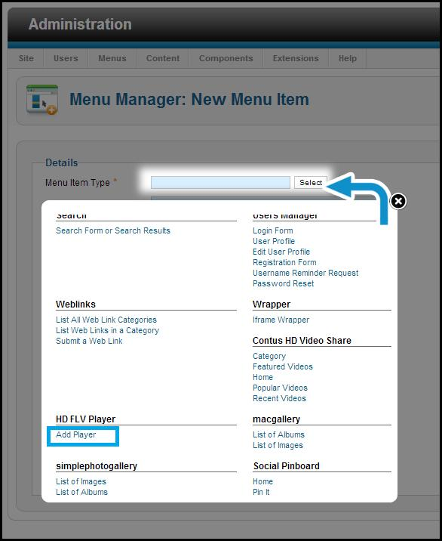

- Select the specific menu you want the new menu item to appear in using the Menu Location drop-down list.

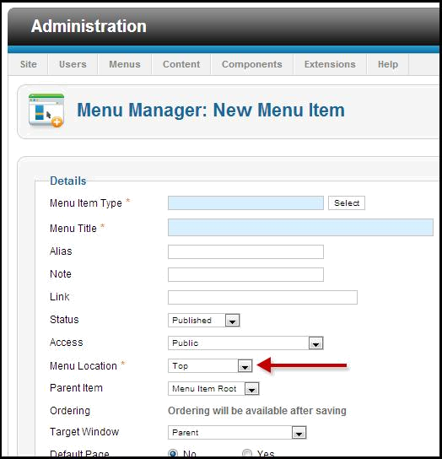

- Click Save or Save & Close to publish the menu item, and close the Menu Manager: New Menu Item page.
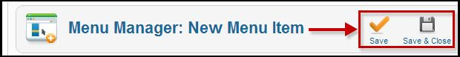

The menu item is successfully created. Now, you can visit the frontend with the menu created for HD FLV Player.

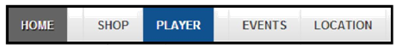

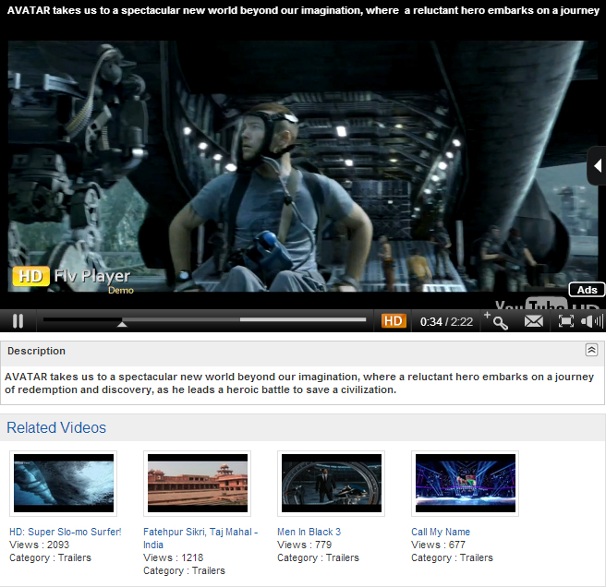

46 | Page

Configuring HD FLV Player Component:

To configure HD FLV Player component go to Admin login > Components > HD FLV Player.

Videos –To Manage Videos:
This is the first tab and it is responsible to add videos into our component.

The HD FLV Player accepts both streaming and normal videos. By default it is set to none where you can add videos through following methods: Upload, Direct URL, YouTube URL, and FFMPEG.

We few common options provided while adding an videos,

- Title - This gives a title for the video added.
- Description - This provides an individual description for the video added.
- Playlist Filter - This option is provided to filter the playlist name added.
- Playlist Name - This option is used to view the playlist added in drop down box.
- Access - There are kinds of access level defined while adding the videos.
- Ordering - This specified the order level for the video added.
- Pre – roll ads - This option is to add any ads before the video and have two options enable/disable the ads.
- Post – roll ads - This option is to add any ads after the video and have two options enable/disable the ads.
- Mid – roll ads - This option is to provide a text ad for the video and have two options enable/diable the ads.
- Download - This option provides to either enable /disable the video for download in the player banner.
- Status - We have two status published/unpublished for the video added.

46 | Page
Adding Videos Through Upload Method:

Four fields are visible when Upload is selected.

- If you would like to let users to switch videos between HD and Non-HD types, then you have to upload videos in both HD and Non-HD formats.

- If you don’t want to give the users a choice, then you can upload any one of the videos, either HD or Non-HD. Leave the second field “Upload HD Video (optional)” as blank.

- After uploading the videos, you also have to upload thumb image and preview it for the respective video. Below this, there is a video info section where you can add Title, Description, Target URL for the video, assign playlist, sort order(recently we have added Ajax sorting where you can sort the videos simply by clicking and dragging from the Videos tab), enable post- ,pre- ,mid-roll ads and download for this video.

Adding Videos through URL Method:
Upload the videos and images through FTP to any location on your web server. For instance, you can add videos to videos folder and images to images folder on your web server and provide the absolute path here.
Like this:

Video URL - http://www.yourdomain.com/videos/video.mp4

Thumb URL - http://www.yourdomain.com/images/image.jpg

Below this, there is a video info section where you can add Title, Description, Target URL for the video, assign playlist, sort order(recently we added Ajax sorting where you can sort the videos simply by clicking and dragging from the Videos tab), enable post- ,post-roll ads, mid roll and download for this video.
46 | Page

Adding videos from YouTube:
To avoid bandwidth consumption from your web server, you can also add videos to the YouTube and can provide YouTube link here. You can get the YouTube URL of the video from the top of the YouTube website.

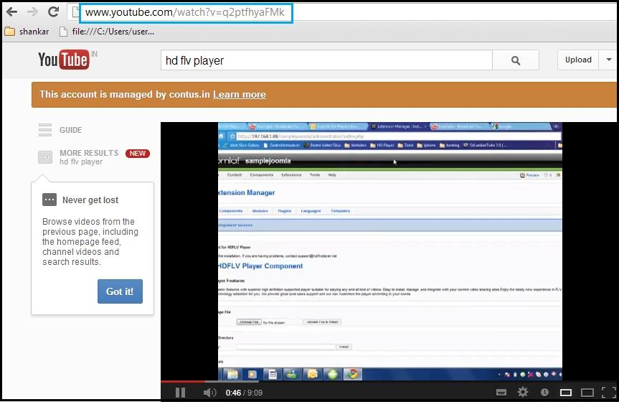

Below this, there is the video info section where you can add Title, Description, Target URL for the video, assign playlist, sort order(recently we added Ajax sorting where you can sort the videos simply by clicking and dragging from the Videos tab), enable post- ,pre-roll ads , mid-roll and download for this video.

46 | Page
Adding videos through FFMPEG:
Before you start uploading the videos using FFMPEG, make sure that you have provided the path of your FFMPEG on the HD FLV Player settings.

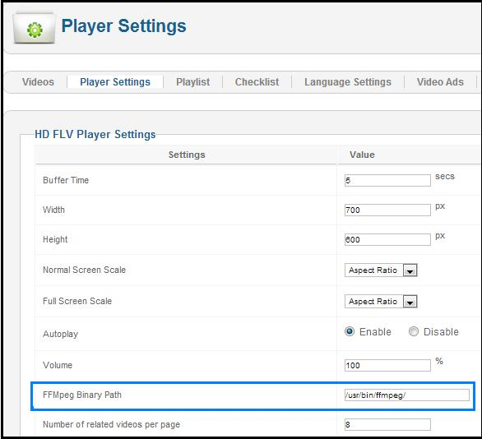

If you are not sure about the path, please check with your hosting provider for the details. After you set the path to FFMPEG you can upload any HD files to convert it to lower resolution automatically.

46 | Page
You need not upload thumb or preview image when using FFMPEG as it will be created automatically. Below this, there is a video info section where you can add Title, Description, Target URL for the video, assign playlist, sort order(recently we added Ajax sorting where you can sort the videos simply by clicking and dragging from the Videos tab), enable /disable post- ,pre-roll, mid roll ads and download for this video.

Adding Videos through RTMP:

With HD FLV Player we can stream RTMP videos, the RTMP video URL will be rtmp://streamer path/video file

For instance: rtmp://edge01.fms.dutchview.nl/botr/bunny.flv

Streamer path = [protocol]/[server name]/[application]

URL= [stream name]

- [Protocol]: You can use the following protocols: rtmp, rtmpt, rtmpe, rtmpte, rtmps.
- [Server name]: this is the IP Address, or the domain name of your server. (i.e., localhost).
- [Application]: use “vod” unless you have changed the name of the folder.
- [Stream name]: use the name of your video file (including the extension).

rtmp://localhost/vod/mp4:mystream.f4v
rtmpe://localhost/vod/myvideo.flv

46 | Page
When adding RTMP videos we need to provide few options:
- Streamer Path - You need to provide the streamer path as “edge01.fms.dutchview.nl/botr.”
- Is Live - This option is to enable/disable whether the video is live or not.
- File option - By Default the file option enabled for RTMP video is URL method.
- Video URL - You need to provide the video URL as “bunny.flv.”
- Thumb URL - You can provide the thumb URL as “car.jpg.”
- Preview URL - This is just a preview option provided for Thumb image.

Adding Videos through Lighttpd:

With HD FLV Player you can stream Lighttpd videos. For streaming Lighttpd videos, we need to provide with following options:
- Video URL - Provide the video URL.
- Thumb URL - You can provide the thumb image for video using thumb URL.
- Preview URL- This is just a preview option provided for Thumb image.

Sorting/ordering the videos:

Ordering or sorting the videos on HD FLV Player component has become simpler now. It can be done easily by drag-and-drop.

46 | Page

Player Settings - To Configure Player :

This is the global settings for HD FLV player. It has five sections: HD FLV Player, Logo, YouTube, Ads, and Front page settings.

HD FLV Player Settings:

- Buffer time - You can set the buffer time of the player to save portions of a streaming Media file to local storage for a playback.
- Width - You can specify the width of the player in pixels (px).
- Height - You can specify the width of the player in pixels (px).
- Normal screen scale - You have three choices to set. Aspect ratio which controls the player size proportionally, fit-to-screen which plays the video to the player size that Declared, Original size plays in original video size irrespective of the Player size declared.
- Full screen scale - This setting affects only on full screen mode.
- Auto play - If it is enabled, video will start playing without users clicking the play option, else you need to select play button if option is disabled in backend.
- Volume - You can set the default volume level when the video plays.

46 | Page

- FFMPEG binary path - Declare the FFMPEG path given by your hosting provider if you are using FFMPEG to upload videos. You can leave it as it is if you are not aware of FFMPEG.
- Number of related videos per page - You can limit the number of thumbs which are needed to be displayed at the Bottom of the player per page for component.
- Playlist Auto play – You have two options for playlist auto play (enable/disable). If you enable the option it will start playing all the videos from the playlist. If you want to disable the option you need to select with play button for each videos.
- Playlist open - You can set playlist to open/close always by enabling/disabling this option.
- Logo alpha - You can set the transparency rate for the logo on the player.
- Skin auto hide - You can enable or disable player controls to be displayed on the player.
- Stage color - Set the background color for the player in the format ffffff.
- Skin - Choose one of the four available skins according to your website design.
- Full screen - Full screen button can be disabled from here for player control.
- Zoom - Zoom button on the player control can be disabled/enabled here.
- Timer - Timer on the player controls can be enabled/disabled.
- Share - Share button on the player can be disabled from here.
- HD Default - You can set the HD videos to play by default. Make sure you have declared HD Video path/uploaded HD videos.
- Related Videos - You can decide where you want to display related videos. Either you can Have it within the player or below the player or on both positions.
- Login Page Link - Enter Login page URL.
- Embed Code- It is mainly used for embedding video onto web page.
- Google Analytics- It is a service offered by Google that generates detailed statistics about the visits to a website. You can enable/disable this option.
- Google Analytics ID- Google analytics ID is provided to have a track of your site. If you don’t have one refer this link to create ID :
https://support.google.com/analytics/bin/answer.py?hl=en&answer=1008080
46 | Page

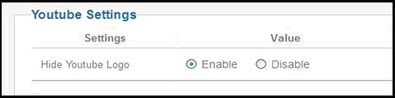

46 | Page
Logo settings:

Demo logo will be removed only if you provide the license on the License Key field which you can obtain by purchasing online from our Website. If you are using the free version simply click on “Buy now” button to purchase the license.
Now you can upload the logo by clicking change button. HD FLV Player accepts jpg/jpeg, gif, and png formats.

- Logo URL - Enter your website URL, so that when someone clicks on the logo it will take them to the corresponding site.
- Logo Position - You can set the position of the logo. You can place the logo in top left/right and bottom left/right.

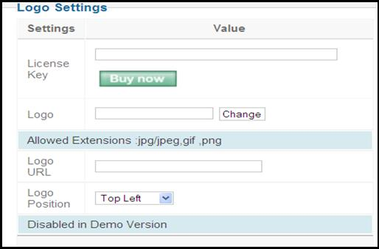

46 | Page

Ads Setting:
This is the global setting to enable/disable ads for the player.

Pre/Post roll Ads Settings:

You can enable/disable pre-roll, post-roll, Random and Google ads.

- Pre- roll ads - You can enable/disable the pre-roll ads.
- Post - roll ads - You can enable/disable the post-roll ads.
- Google ads - You can enable/disable the Google ads.

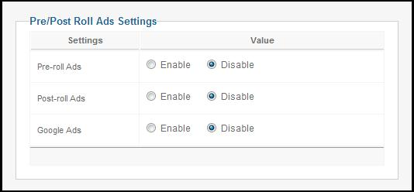

Mid-roll Ad Settings:

You can enable/disable mid-roll ads and can set the settings for mid-roll ads as well, such as:

- Begin - It tells when the mid-roll ads should begin in seconds.
- Ad Rotate - You can rotate the mid-roll as per added and also can be enabled/disabled.
- Mid-roll Ads Random - This option helps to show the mid-roll ads randomly and also can be enabled/disabled.
- Ad Interval - You can mention like when there raises a break for ads using Ad Interval.

46 | Page

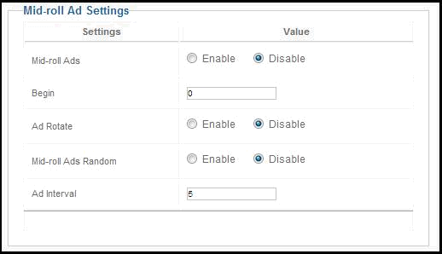

Front page Settings:

- Title above the player - Here you can enable/disable the title of the player.
- Description below the player - Here you can enable/disable the description of the player.
- Times Viewed - Here you can enable/disable the times viewed option to view the number of times the video is been viewed by user.
- Playlist Drop-down - Here you can enable/disable the playlist drop-down provided above the player.

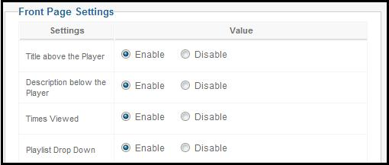

46 | Page

Playlists – To Manage Playlists:

You can create a playlist by which you can categorize the videos. You can add multiple videos to a particular category (playlist) and can assign the playlist to the individual modules or plugins to use players on different pages with different playlists.

Language Settings – To Change Player language:

The HD FLV Player accepts captions in all languages. You can change any text on our player in your own language without the necessity of the source file. Simply mention the name of the language and start typing the caption by using native language support keyboard.
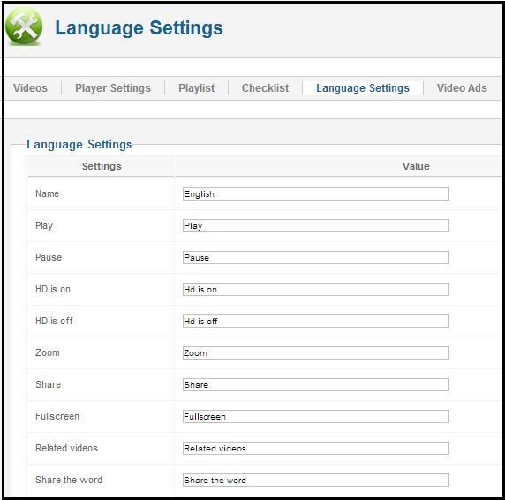

Video Ads – To Manage Video Ads:

Pre-/Post-Roll:

Here you can upload or provide URL to the video ads which can be set as pre- or post-roll ads while adding videos. Also you can provide Ad Name, Ad Description, Target URL, Click Hits URL, and Impression Hits.

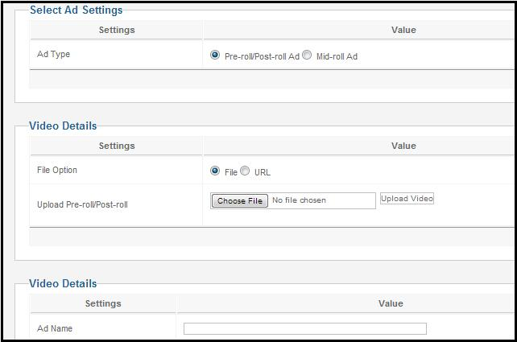

Mid-Roll:

Mid-roll ads are text ads displayed while the video is playing. Here you can set different ads for individual video with duration and order. Here you can add new mid-roll ads and provide details of the ad such as Ad name, Ad description, Target URL, Click hits URL, and Impression hits URL.

46 | Page

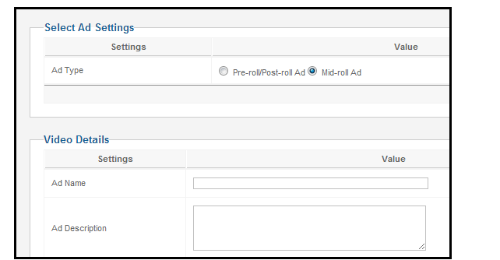

- Ad Name - This provides a title for pre-/post-/mid-roll ads.
- Ad Description - This provides a description for pre-/post-/mid-roll ads.
- Target URL - When you provide an URL, click on the video ads, which in turn redirects to the URL mentioned in Target URL.
- Ads Visits URL - A click is counted when a user clicks on a banner or text link.
- Impression Hits URL - An impression is counted whenever a banner link with creative hosted by Google Affiliate Network is served.

You have the option to publish/unpublish for both pre-/post-roll ads and mid-roll ads.

46 | Page

Google Adsense:

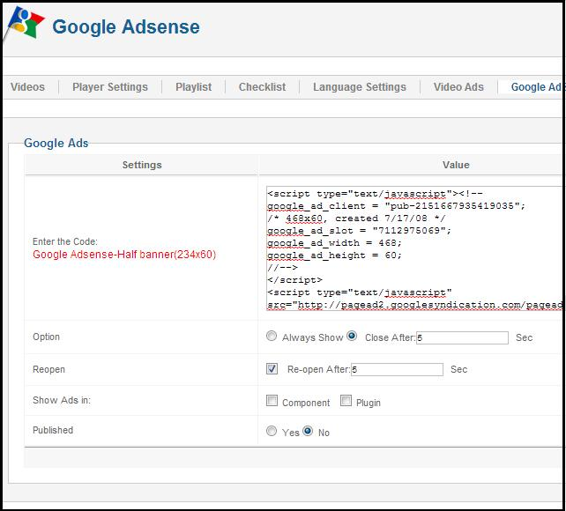

Simply add the script from ad sense, adbrite or your own custom script to display ads on the player.

- You can also set accordingly, if you want to close the ad automatically after a few seconds or leave it open always.
- You can set it like to reopen the ad after a few seconds even if somebody closes the ad.
- You can decide on whether to show ad in component or module or plugin or on all locations.
- You can also publish/unpublish the Google ads.

46 | Page

HD FLV Player Module

Using HD FLV Player Module:

The HD FLV Player module controls can be found in the module manager section.
Go to Back end > Extensions > Module Manager > HD FLV Player

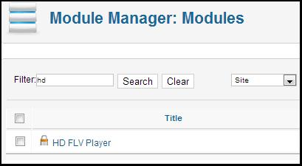

After selecting this, you can assign the position for module.

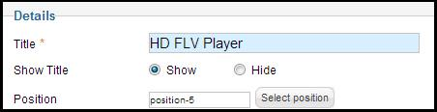

You will be able to control the module settings from here as you do in component. With respect to adding videos you can either assign single video or the playlist itself. When you add/assign single video make sure that particular video is already added in the component.

46 | Page

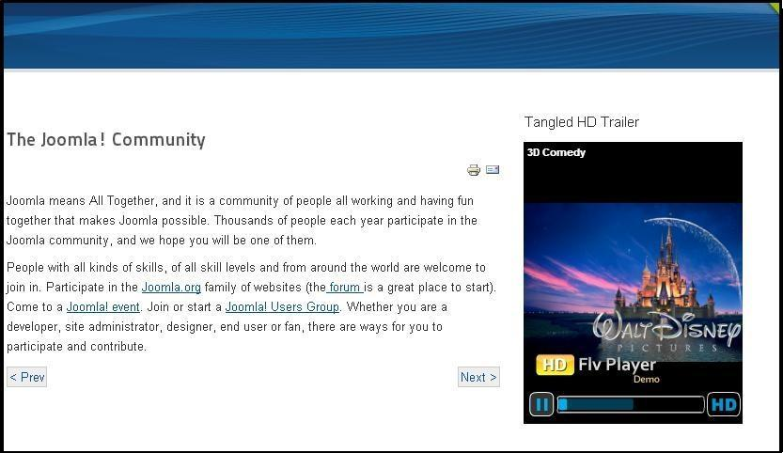

Module Basic Options:

✓ Enable-related videos within player - You have the option to enable/disable the related videos within the player.
✓ Enable-related videos outside player - You have the option to enable/disable the related videos outside the player.
✓ No of column- You can specify the number of columns for related videos in module. 
✓ No of rows- You can specify the number of rows for related videos in module.
✓ Auto play - If it is enabled, video will start playing without asking for user to click play or else we need to select with play button if option is disabled in backend.
✓ Playlist always open - You can set playlist to open/close always by enabling/disabling this option.
✓ Videos type - You can two options like (videos/playlist), by choosing any you can set the module either from added videos or added playlist.
✓ Videos - This shows a list of videos added, so that you can choose a particular video to show as module.

- Playlist auto play - You have two options for playlist auto play (enable/disable). If you enable the option it will start playing all the videos from the playlist. If you disable the option you need to select with play button for each videos.
- Buffer time - You can set the buffer time for the player to save portions of a streaming Media file to local storage for a playback.
- Width - You can specify the width of the player in pixels (px).
- Height - You can specify the width of the player in pixels (px).
- Normal screen scale - You have three choices to set. Aspect ratio which controls the player size proportionally, fit to screen which plays the video to the player size that Declared, Original size plays in original video size irrespective of the Player size declared.
- Screen scale - This setting affects only on full screen mode.
- Volume - You can set the default volume level when the video plays.
- Skin auto hide - You can enable or disable player controls to be displayed on the player.
- Stage color - Set the background color for the player in the format ffffff.
- Full screen - Full screen button can be disabled from here for player control.
- Zoom - Zoom button on the player control can be disabled/enabled here.
- Timer - Timer on the player controls can be disabled/enabled.
- Share - Share button on the player can be disabled from here.
- Title above the player - You can enable/disable the title for the module.
- Description below the player - You can enable/disable the description for the module.
- Times viewed - This option provides that how much time the module is viewed by users; there is also an option to enable/disable.
- Module class suffix - Module Class Suffix is a parameter in Joomla! Modules. Setting this parameter causes Joomla! To either add a new CSS class or modify the existing CSS class.

46 | Page
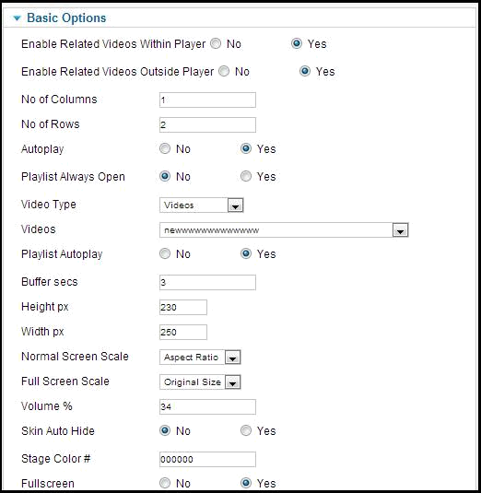

You can also create multiple modules and can assign different playlists which can be used on different pages. You have the option to duplicate the modules. For this, you need to follow a few steps to duplicate the modules.

46 | Page

1. Select the “HD FLV Player” module and choose the duplicate option placed in header part.

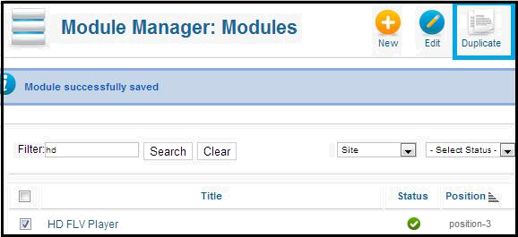

2. By the above method you can duplicate 'n' number of modules. Check the below screenshot.

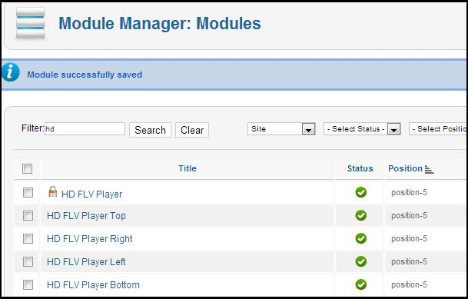

46 | Page

3. Each duplicated modules will their own module setting. By editing any duplicated module can control player options as per our needs.

HD FLV Player Plugin

46 | Page

Using HD FLV Player Plugin:

You have the option to assign a player to any particular articles or page using plugins. To enable plugin:

Go to Back end > Extensions > Plugin Manager > HD FLV Player

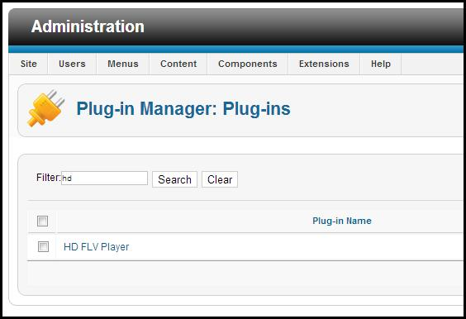

On selecting the above-mentioned plugin, you will get a page with six kinds of plugin codes.

46 | Page
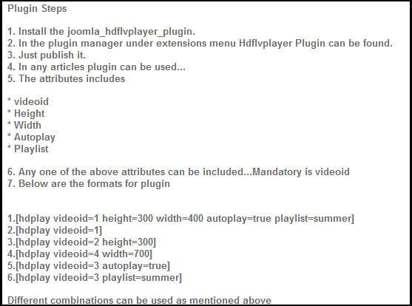

Inserting plugin to the article is very simple. These sample tags can be used to insert the player into the article:

[hd play videoid=1 height=300 width=700 playlist=true auto play=true]

In the above line hd play is mandatory.

- Videoid - You will get the videoid when you add the videos in the component.
- Auto play - If you don’t want to auto start the video you can mention autoplay=”false.”
- Playlist - If this is true then playlist that corresponds with the videoid that declared here will play all the videos from the list.
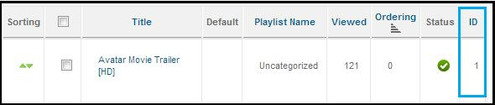

46 | Page
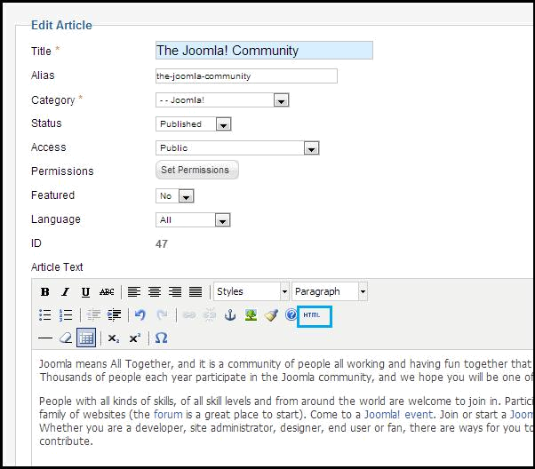

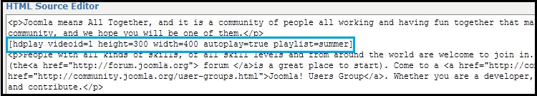

46 | Page

After assigning this code for articles this how it will be displayed in frontend.

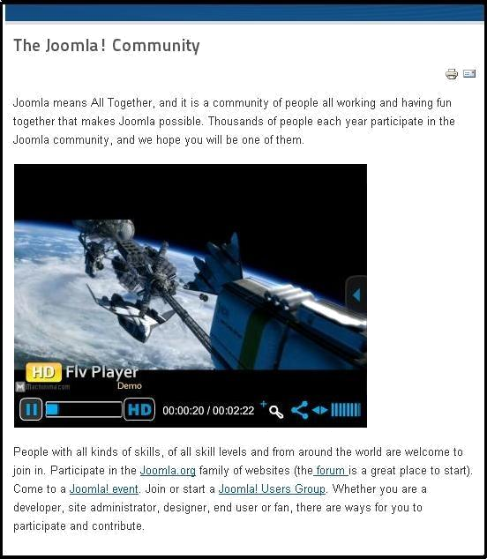

46 | Page

Basic Requirements for Joomla

To successfully install and use HD FLV Player for Joomla sites, you must have a fully operational web server (Apache is the optimum) with Joomla installed.

You can verify most of the below requirements by heading to your Joomla backend on Help > System Info > System Information and PHP Information tab. For any assistance related to your server configuration, you can check with your webhosting provider.

46 | Page

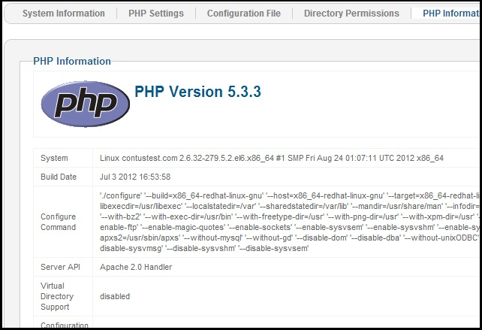

Specific Requirements for Joomla HD FLV Player:

You recommend using the latest stable version of Joomla to enjoy its up-to-date features and security enhancements. However HD FLV Player still supports the minimum requirement of:

For the server, make sure it has:
- PHP 5.2.6 or above
- MySQL 4.1 or above

Also, Joomla HD FLV Payer requires several PHP extensions, which are available in most hosts:

46 | Page

- GD library, at least v1.8 with libjpeg
- cURL library
- zip
- allow_url_fopen in php.ini
- file_uploads in php.ini
- FFMPEG (optional)
That's all you need to learn about the basic functionalities of most HD FLV Players to work with.

Recommendations for Best Performance:
For more advanced features like faster photo and video uploads follow the sections below.

Recommended: ImageMagick; to get it running, it also requires exec/passthru/shell_exec/system access

Video Upload Requirements: Video Linking: Linking from external websites such as YouTube and Vimeo requires only cURL to be installed, which is available on most hosts:

- cURL library

Video Upload (Optional): Video upload uses FFMPEG to convert videos. Most shared webhosts disable this option because it consumes a lot of memory and processing power. Please consult your webhost on the availability of FFMPEG on your server. It is advisable to have at least VPS before you consider allowing video upload. FFMPEG is an optional requirement. It is used only if you want to convert uploading videos.

- Minimum: FFMPEG; to get it running, it also requires exec/passthru/shell_exec/system access

Unlike other extensions, the path to FFMPEG needs to be specified on your HD FLV Player backend.
46 | Page
Large Video/Photo uploads: When it comes to large photo/video uploads, there are a few server configurations that you need for HD FLV Player.

php.ini

max_execution_time= 9000; Maximum execution time of each script, in seconds
max_input_time= 9000; Maximum amount of time each script may spend parsing request data memory_limit= 1024M; Maximum amount of memory a script may consume
post_max_size = 1024M; Maximum size of POST data that PHP will accept.
upload_max_filesize = 1024M; Maximum allowed size for uploaded files.

my.cnf

wait_timeout=120
connect_timeou120

Disable safe_mode and open_basedir

Some hosting providers have safe _mode and openbase_dir enabled. In order to upload the photo/video, you have to disable them. If your hosting allows you to override the Apache's configuration, you need to override the vhost configuration.

php_admin_flag safe_mode off

php_admin_value open_basedir none

If your webhost allows for .htaccess override, locate your .htaccess file in the root Joomla directory and add these lines into it:

php_admin_flag safe_mode off

php_admin_value open_basedir none
Information on memory allocation: HD FLV Player is developed to run adequately on system with just 32Mb memory allocated to PHP. However, please bear in mind that the development site uses the default template with no additional third-party modules & plugins enabled. Sites with third-party plugins and modules enabled will consume a lot of memory; thus, you recommend you to increase your memory limit.

We recommend that you allocate at least 64Mb of memory to PHP. The following task will consume a lot of memory:

    - Resizing uploaded user avatar for optimization.

    - Resizing any photos uploaded by user for optimization.

    - Converting uploaded videos to Flash .swf.

Information on Stability: Before its release, each version of HD FLV Player is thoroughly tested with different web browsers (IE, Chrome, Firefox, Opera, Safari, etc) on main versions of three operating systems Windows, Linux & Mac. You do a regular testing in main browser versions based on the current trend and usage statistics.

46 | Page

Contacting us
Our support team is happy to help with any questions about using product. You may contact our support team through support forum& support tickets

Your question may already be answered!
Forum: www.apptha.com/forum

Before you send us an email or raising tickets, take a look at Apptha.com/forum for any technical issues, common questions and more. We may have already answered your question.

Raise tickets for your specific questions!
Tickets: assist@apptha.com

Send an email to our support team to get answers to your specific questions. Our team will work to respond to your query promptly.

The best place to discuss about additional features!
Email: bdm@apptha.com

46 | Page

